Project 3
CS 557 - Computer Graphics Shaders
Name: Tianle Yuan (933-946-576)
Project Number: 3
Project Name:Displacement Mapping, Bump Mapping, and Lighting
Video Link: https://media.oregonstate.edu/media/t/1_apn2ykyf
Email: yuant@oregonstate.edu
Time: January 26, 2020

- What you did and explaining why it worked this way
There are four steps I worked for this project.
The first step is geometry model construction. This step is finished in the vertex shader, which means for each vertex, I get the new coordinate of Z axis direction by recalculating the equation: z = K * (Y0-y) * sin( 2.*PI*x/P ) according to the original coordinates of X axis and Y axis.
The second step is calculating the normal of the surface. This step is finished in the vertex shader. Normal means the vector that is perpendicular to any vectors on the surface. By considering 2D surface only has 2 degree of freedom, vectors in X axis and Y axis is enough for normal vector’s calculation. The theory of the normal calculation is calculating cross product on each vertex, which means after gotten tangent value from both x and y direction we can get the normal vector in X axis direction.
The third step is Lighting, which has been finished in the fragment shader. The reason that we implement this step in the fragment shader is that we can have smoother curved highlights. After passed normal and eye position value from vertex shader to rasterizer, in the fragment shader, final lighted result is blend of three light effect: ambient light, diffuse light and specular light.
The final step is Bump-Mapping. In the project, I used the 3D noise to recalculate the normal of original 3D surface normal by using normal rotation matrix. The result of the rotation is the new normal that can show the effect that lighting is based on the “eroded geometry”. The reason that I used the quotation mark is that the erosion effect is not because of real shape deformation but only the changed surface normal.

- Side-by-side images showing different values for the input parameters
There are several major input uniform parameters used in the project. They are: uK, uP, uNoiseAmp, uNoiseFreq, uKa, uKd, uKs, uShininess, uLightX, uLightY, uLightZ, uColor, and uSpecularColor.
uK is the parameter control the amplitude of ripple:
When uK = 0.0:
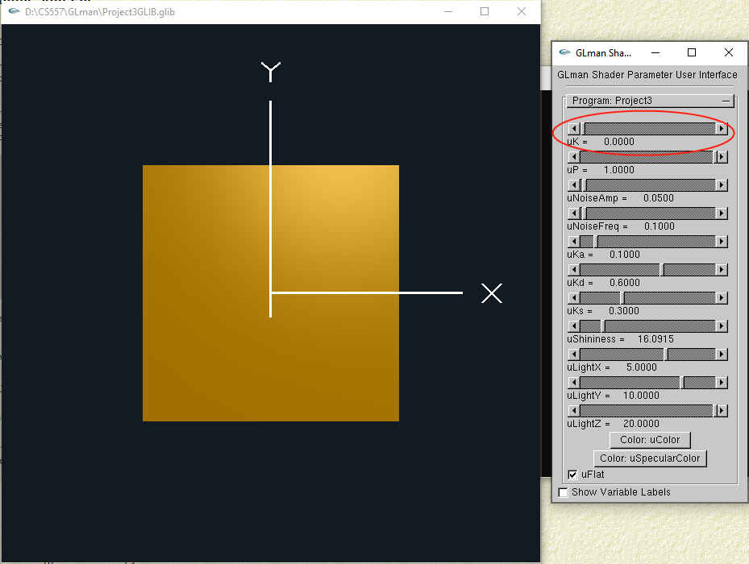
When uK > 0.0:
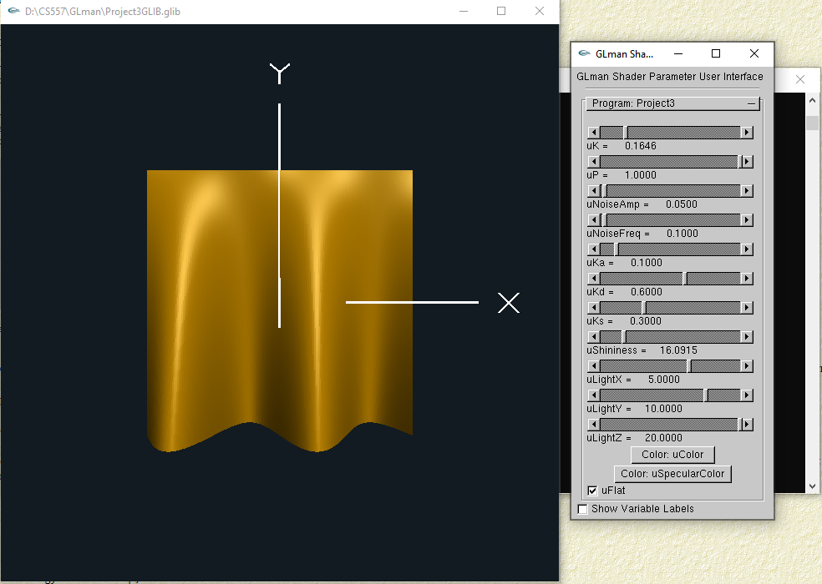
uP is the parameter control the frequency of ripple:
When uP = 1.0:
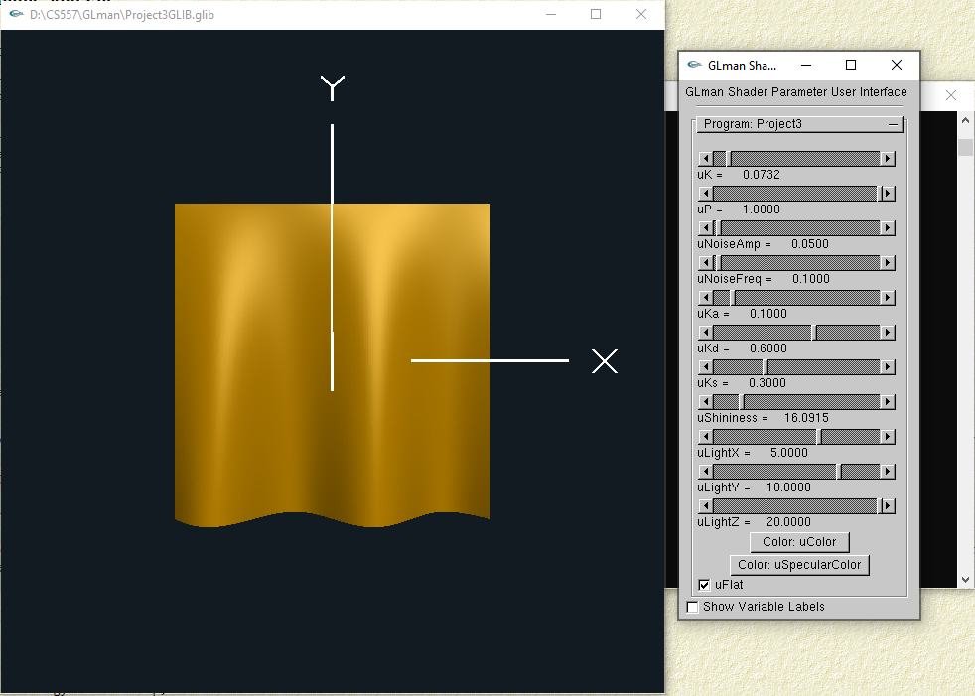
When uP < 1.0:
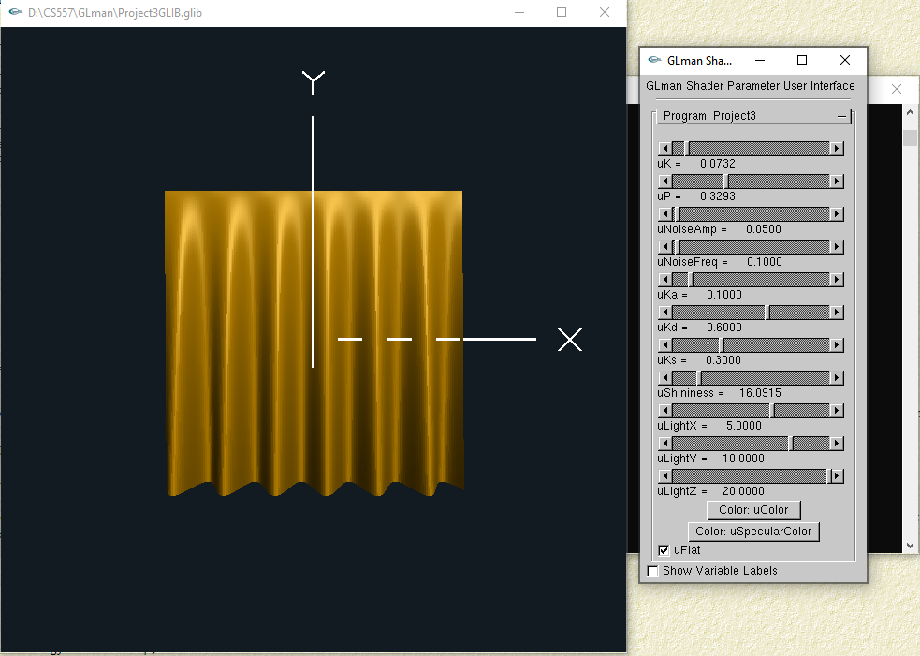
uNoiseAmp is the parameter control the degree of noise Bump-Mapping:
When uNoiseAmp = 0.0:
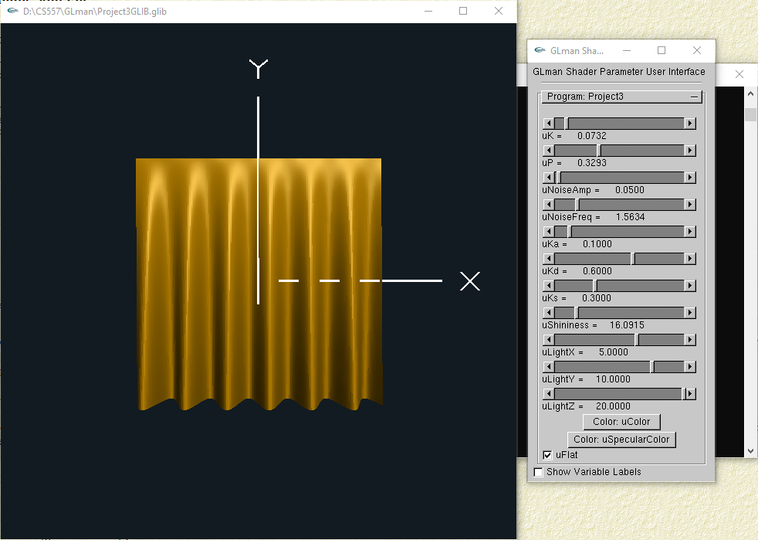
When uNoiseAmp > 0.0:
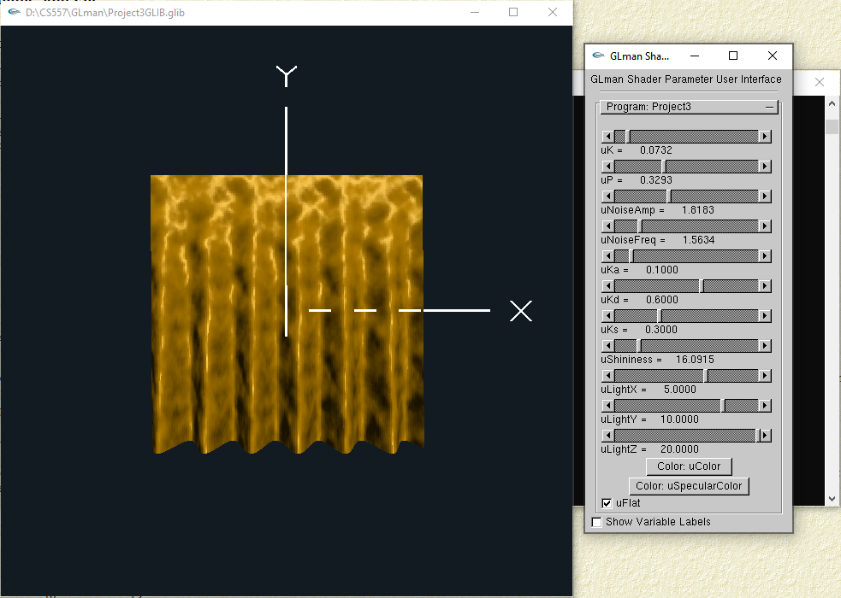
uNoiseFreq is the parameter control the frequency of noise Bump-Mapping:
When uNoiseFreq near 0.0:
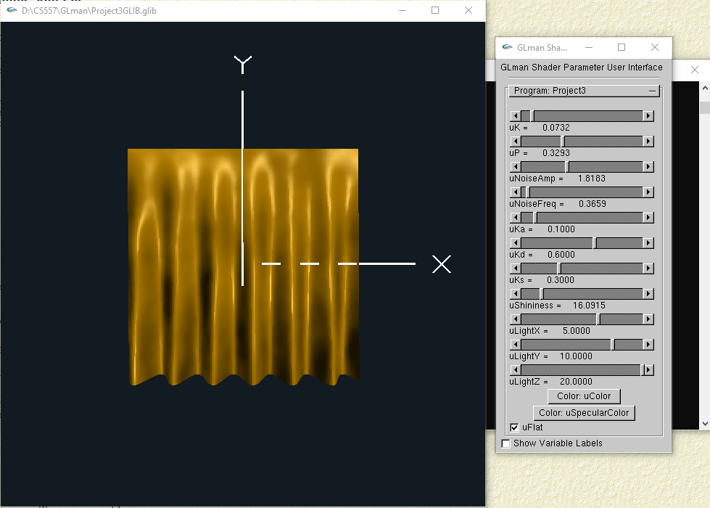
When uNoiseFreq farther larger than 0.0:
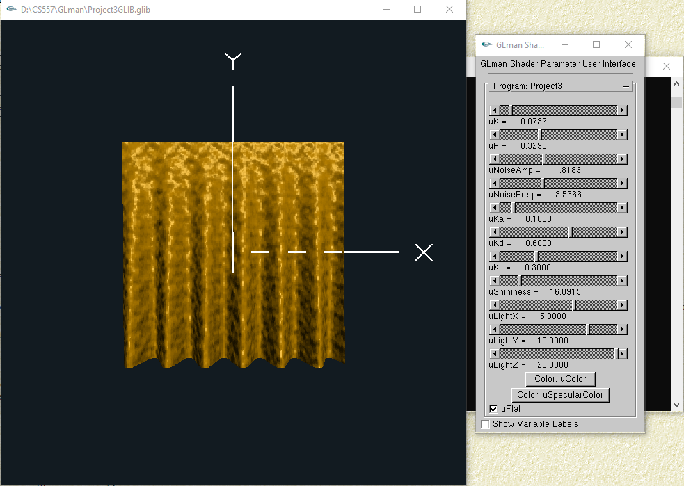
uKa, uKd, uKs are the parameter show the light effect of ambient, diffuse and specular:

When there is only uKa, there is only color of the curtain:
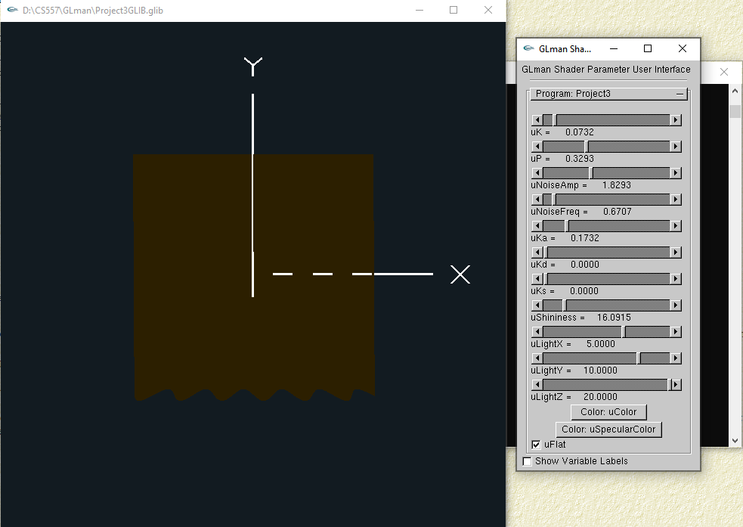
When there is only uKd, there is only shadow and part color of the curtain:
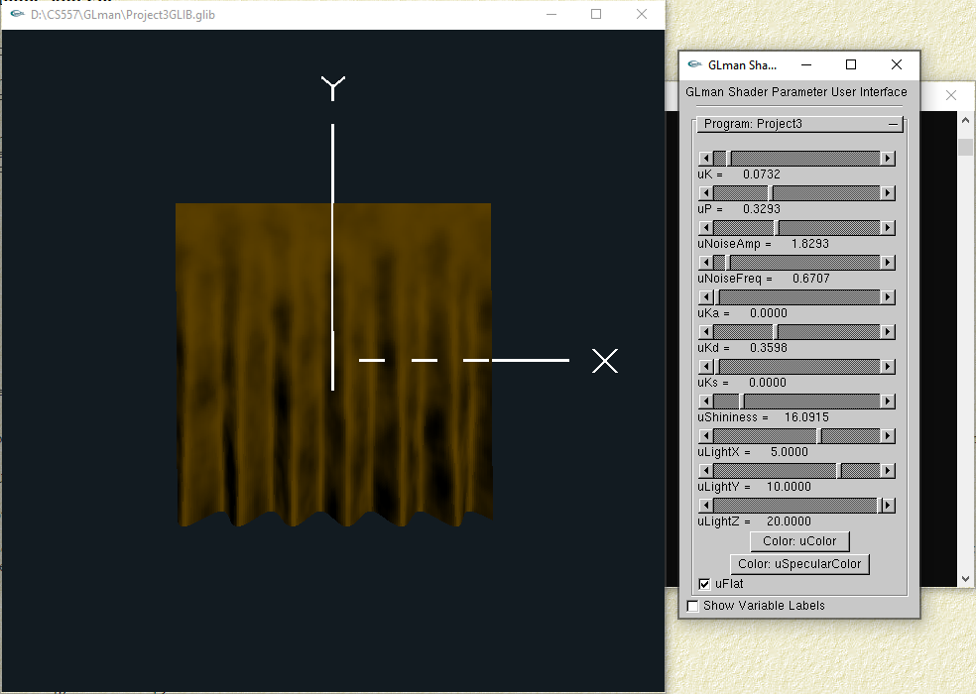
When there is only uKs, there is only highlight of the curtain:
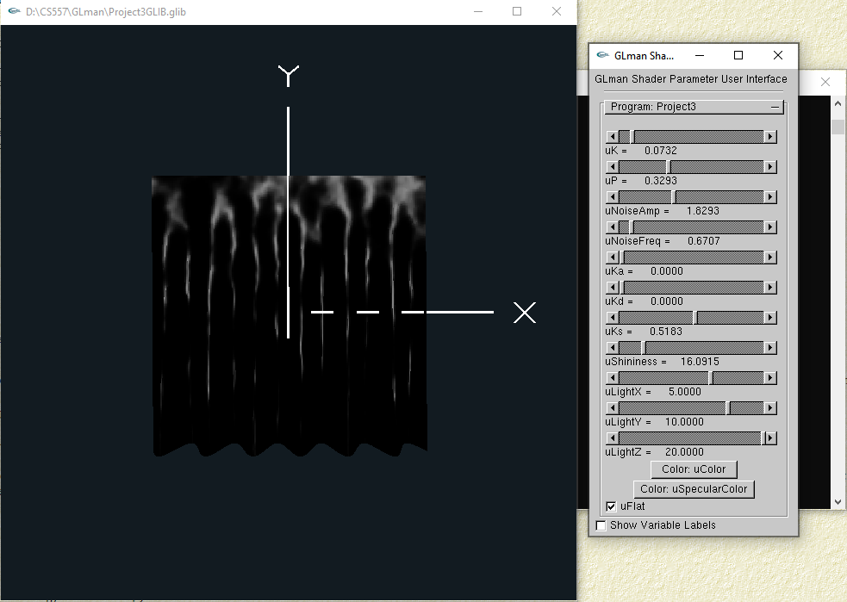
uShininess is the parameter that used to control how shiny the surface is:
When uShininess = 1:
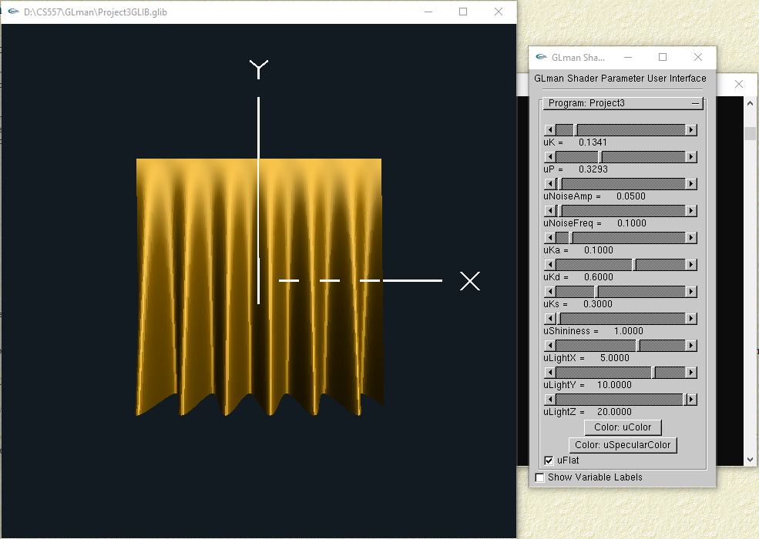
When uShininess > 1:
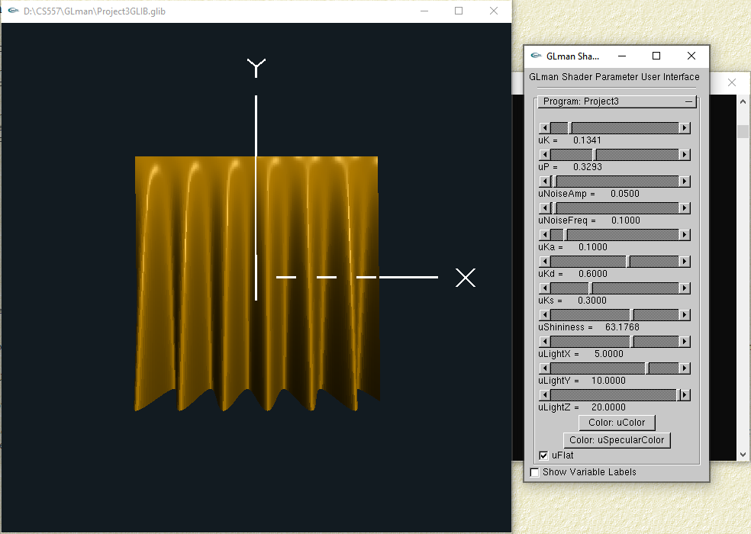
uLightX is the parameter that used to control the light source on X axis direction:
When uLightX = -20.0:
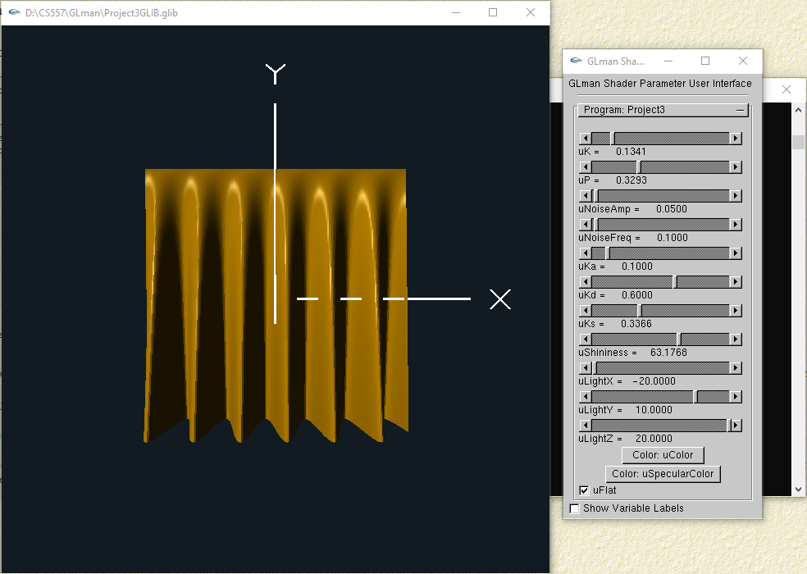
When uLightX = 20.0:
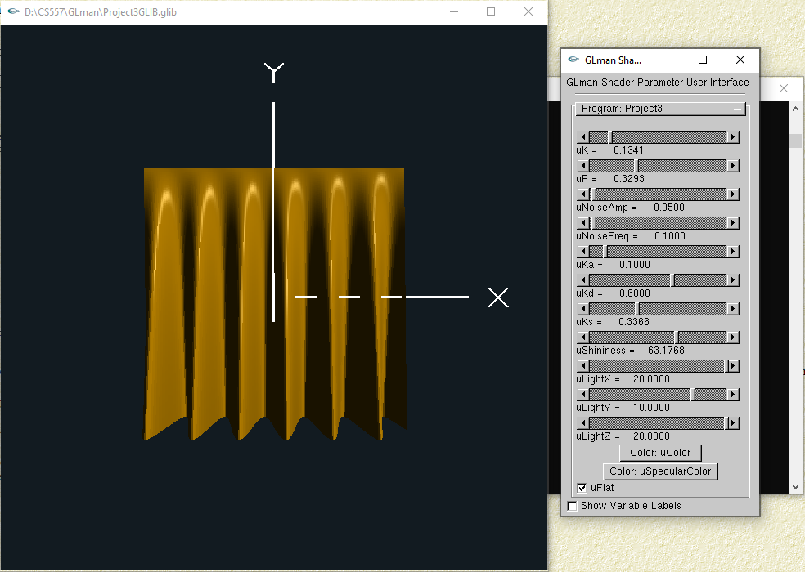
uLightY is the parameter that used to control the light source on X axis direction:
When uLightY = -20.00:
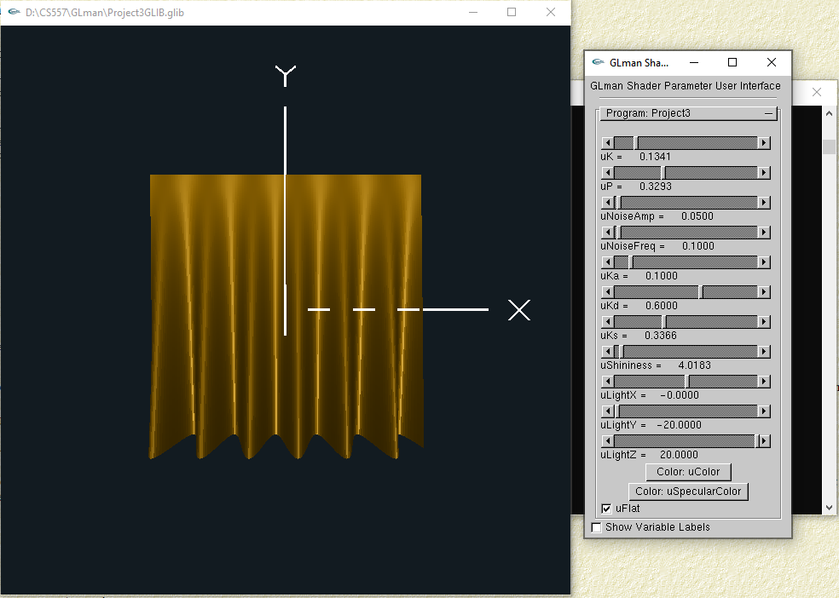
When uLightY = 11.95:
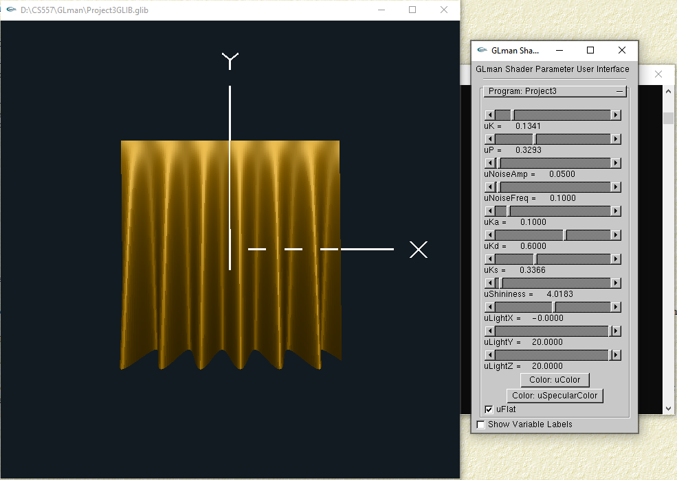
uLightZ is the parameter that used to control the light source on X axis direction:
When uLightZ = 20.00:
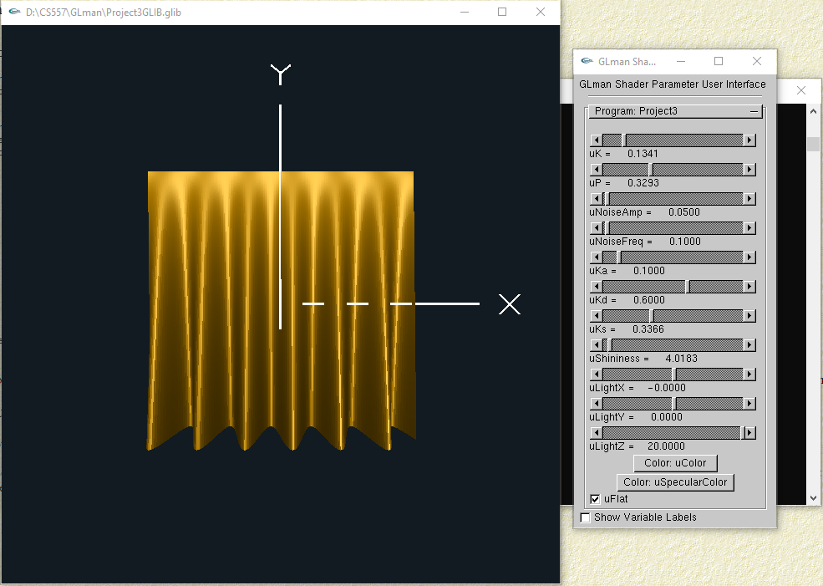
When uLightZ = 0.00: (At this time, the light is lighting the back of the curtain)
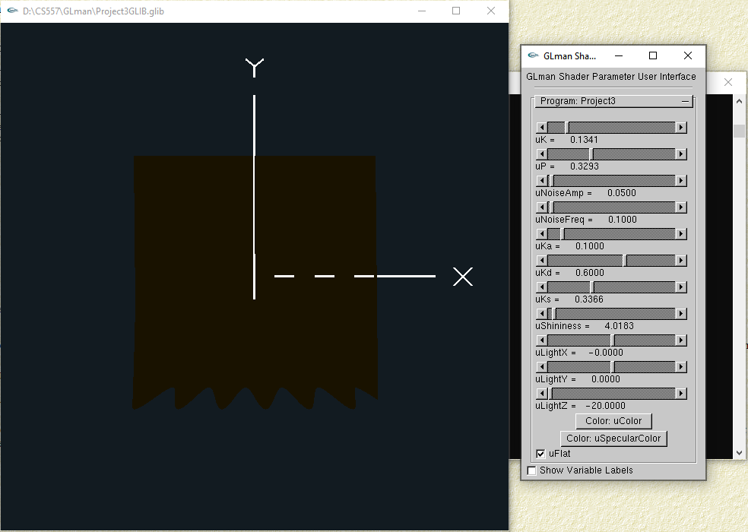
uColor, and uSpecularColor are primitives used to change colors of the curtain and color of high light:
When we want to change the color of the curtain, we click uColor bottom:
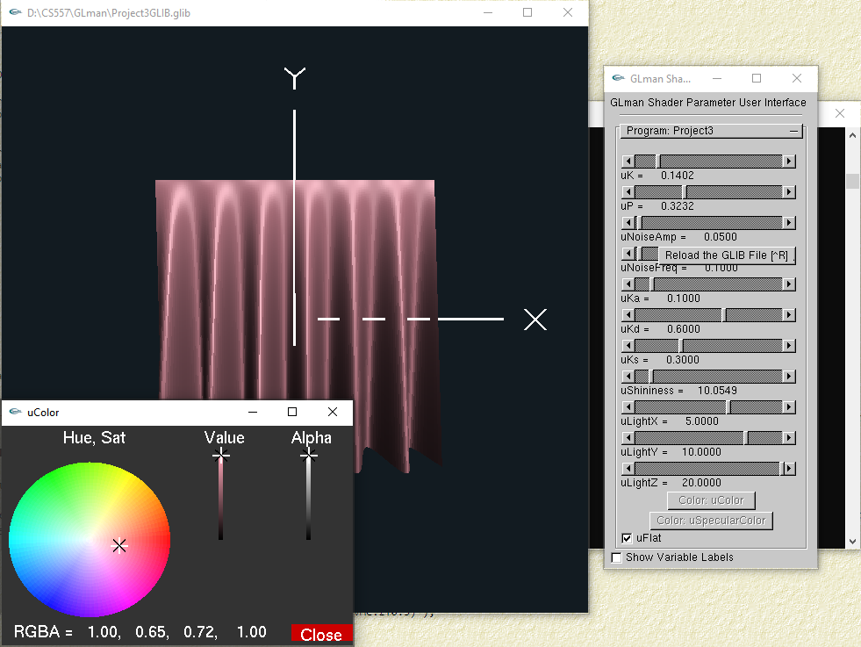
When we want to change the color of the curtain, we click uSpecularColor bottom:
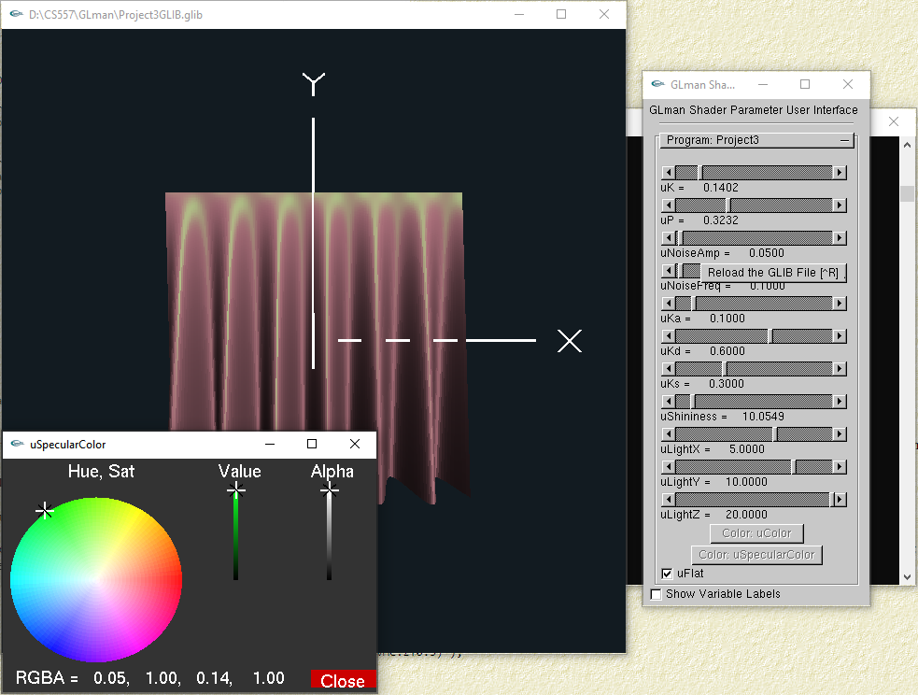
- Per-fragment lighted image(s) showing that your normal computation is correct.
To prove the normal computation is correct, we only need to check the high light and shadows are correct when we change the location of light source:
Moving light from left to right, when light is at the bottom position:
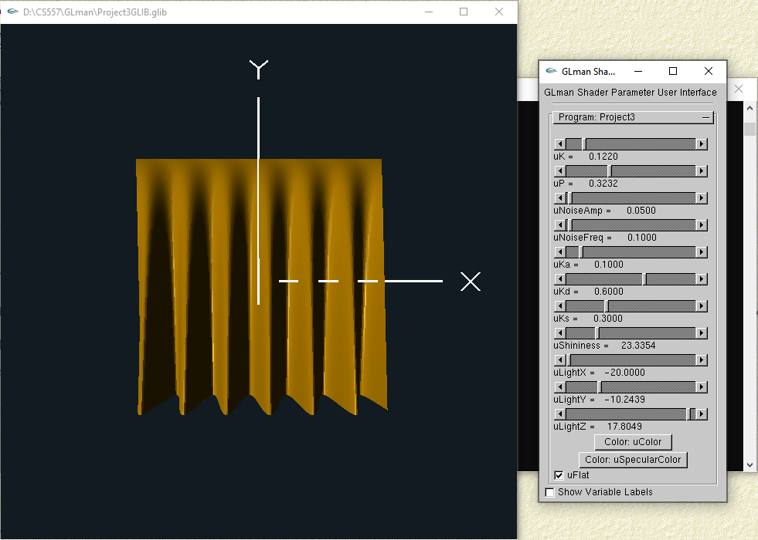
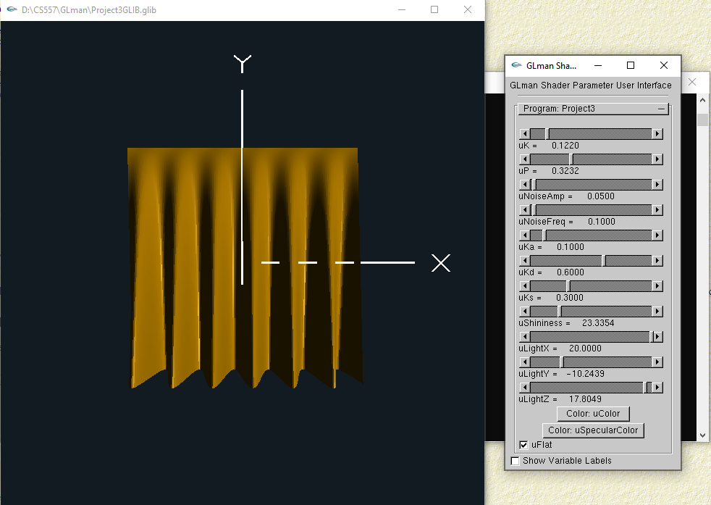
Moving light from left to right, when light is at the top position:
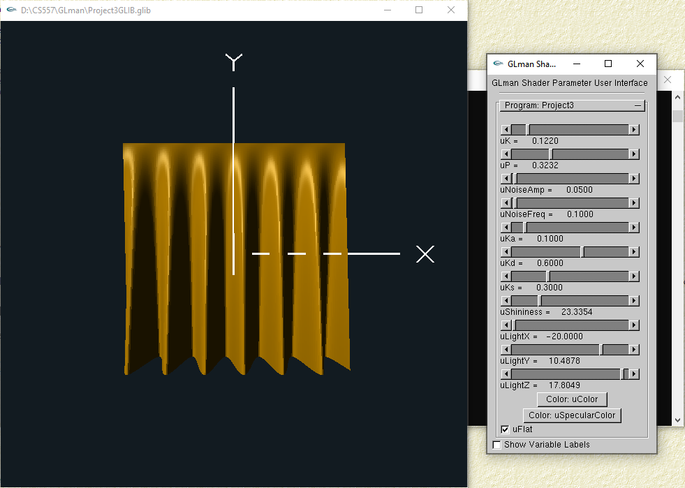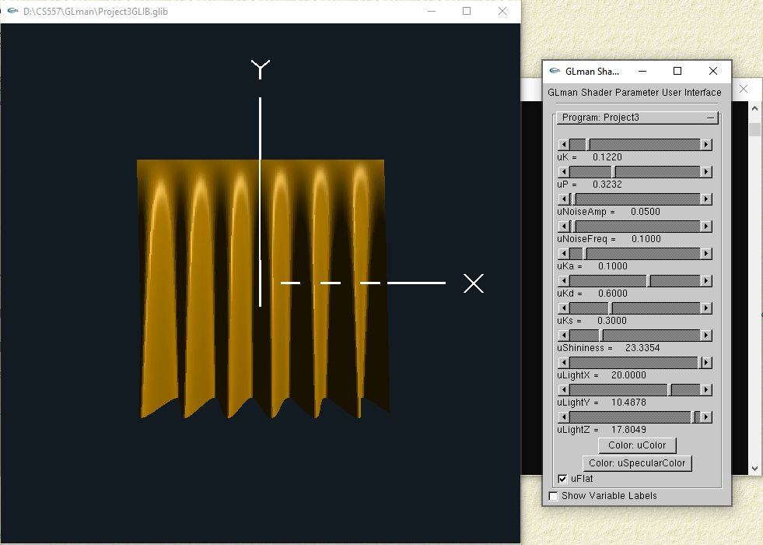

- Per-fragment lighted image(s) showing that your bump-mapping is correct.
To prove the bump-mapping is correct, we only need to check the high light and shadows (the new normals) are correct when we change the location of light source after we open the noise mapping:
Open the noise mapping, moving light from left to right, when light is at the bottom position:
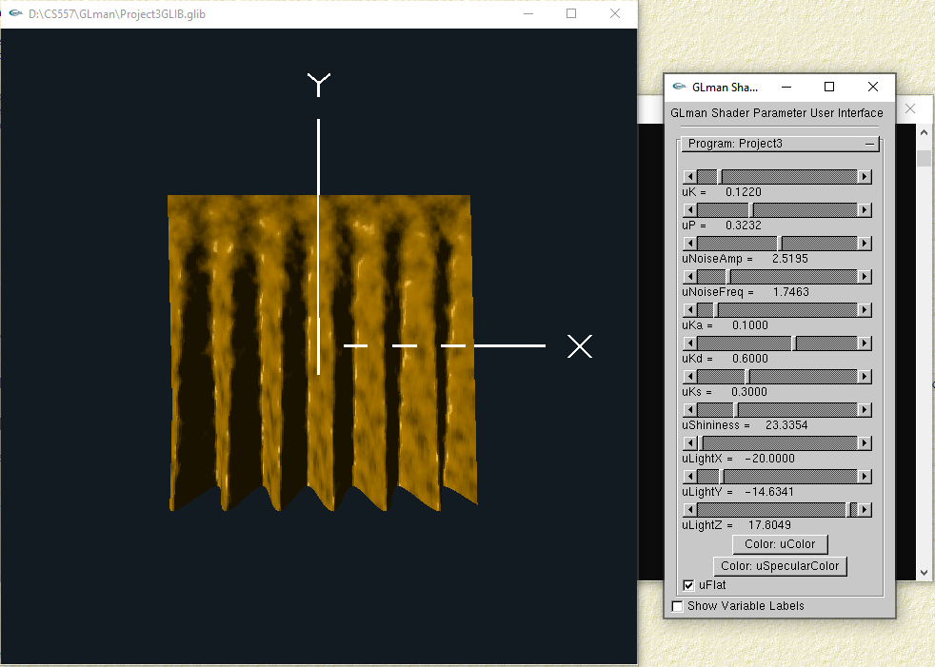
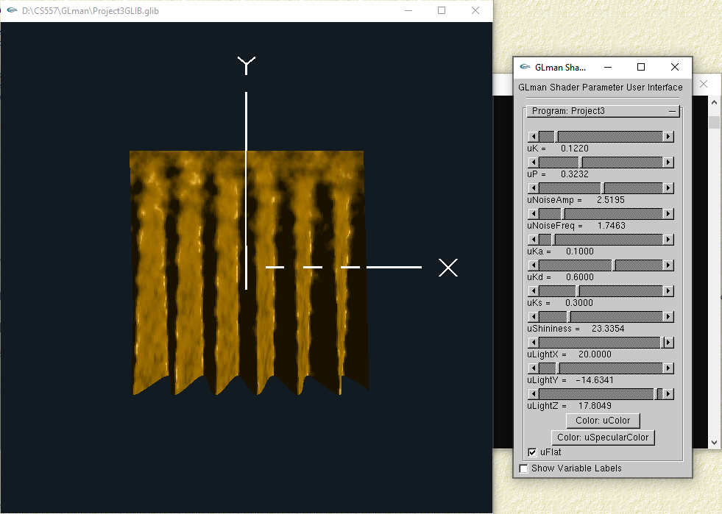
Open the noise mapping, moving light from left to right, when light is at the top position:
